TeamMates
The mission of the TeamMates Mentoring Program is to positively impact the world by inspiring youth to reach their full potential. TeamMates began in 1991 with the vision of University of Nebraska Head Football Coach Tom Osborne and his wife Nancy. The program began with twenty-two football players who met with middle school students in the Lincoln Public Schools. TeamMates has expanded and currently there are more than 6,500 youth in 117 communities across Nebraska, Iowa and California! Will you give one hour a week to inspire hope in a student? Contact: http://teammates.org/

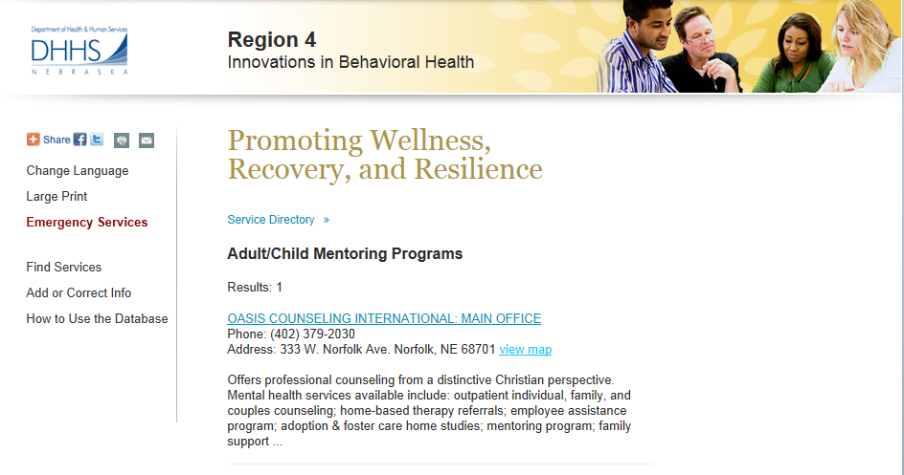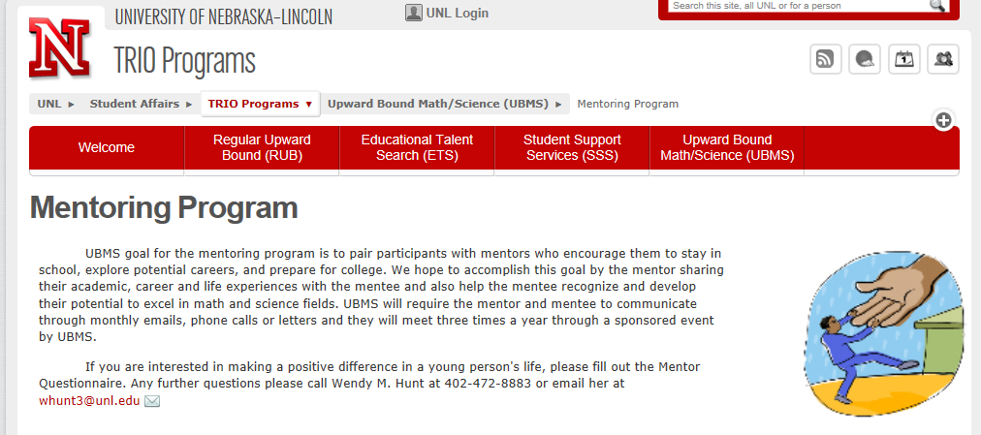

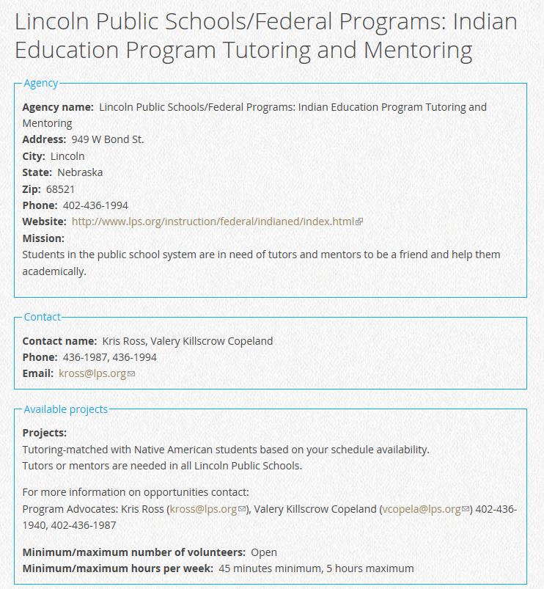
Numerous Big Brothers / Big Sisters Programs in Nebraska

Big Brothers Big Sisters of Grand Island
Serving Hall, Hamilton, Howard & Merrick Counties
Office is located at:
424 W. 3rd Street
Grand Island, NE 68801
Lower Level, US Bank Building
Phone: (308) 384-3456
Fax: (308) 385-5517

Program Office
Dawes Middle School
5130 Colfax Ave.
Lincoln NE

402-464-2227 - phone
402-464-3742 - fax

Administrative Office
6201 Havelock Avenue
Lincoln, NE 68507

Big Brothers Big Sisters of the Midlands
10831 Old Mill Road, Suite 400
Omaha, NE 68154
402-330-2449 - phone
402-330-2492 - fax

